**A PROJECT REPORT**

### ON

**E-Commerce Website**

**For the partial fulfillment for the award of the degree of**

**BACHELOR OF TECHNOLOGY**

#### In

**COMPUTER SCIENCE AND ENGINEERING**

**Submitted By**

**Mudassir Hussain (1901920100172)**

**Mohit (1901920100168)**

**Under the Supervision of**

**Dr. Deepti Mishra**



**G.L. BAJAJ INSTITUTE OF TECHNOLOGY &**

**MANAGEMENT, GREATER NOIDA**



**Affiliated to**

**DR. APJ ABDUL KALAM TECHNICAL UNIVERSITY,**

**LUCKNOW**

**2021-22**

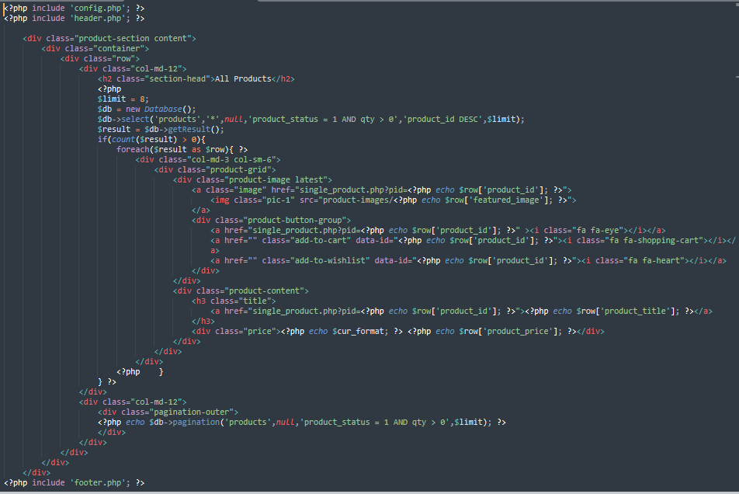

Figure 5: Basic PHP of the Project

**5.2.2 Basic CSS of the Project**

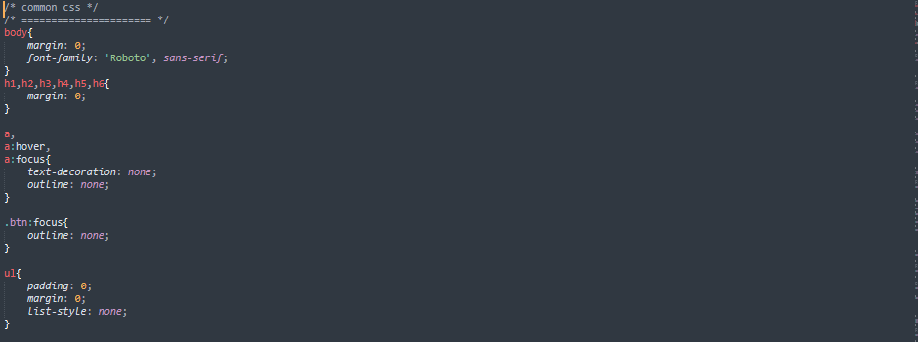

Figure 6: Basic CSS of the Project

**5.3.3 Available products on the website**

Any user with an internet connection can access the online shop. The user can surf the webpage to

see what is available on the website. To get the product, we create a function called which also has a connection to the database. When function is called a relationship is established in the database to

retrieve products from the database.



Figure 7: Available products on the website

**5.3.4 User Registration**

The User will insert his personal information into the registration form.

After submitting the form, a connection is established with the database which saves the data.

The IP address of the customer is also sent to the database to be kept.

The user is expected to provide the necessary information.

Any missing space or wrong information may lead to the customer not being able to register.

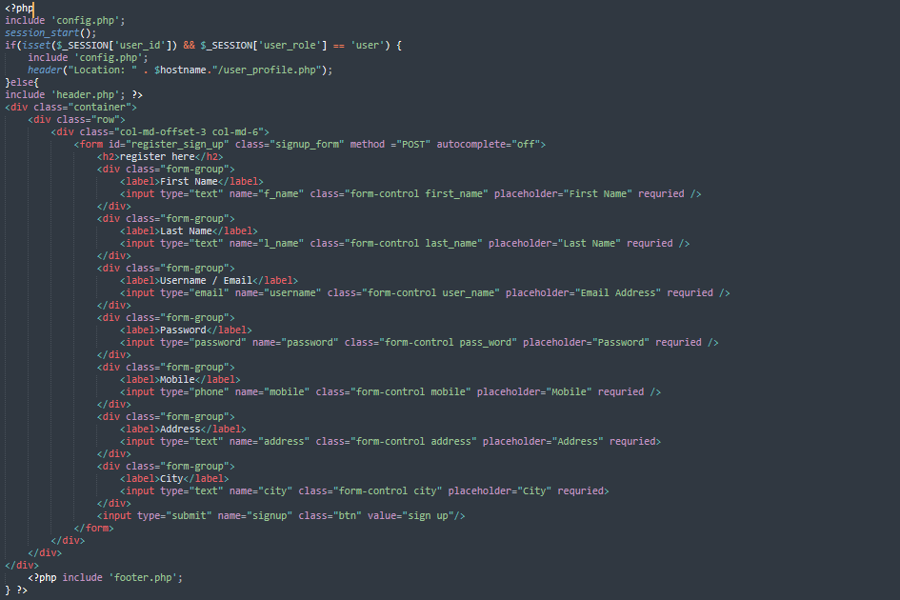

Figure 8: User Registration

**6.2 Screenshots of the project**

* Home Page

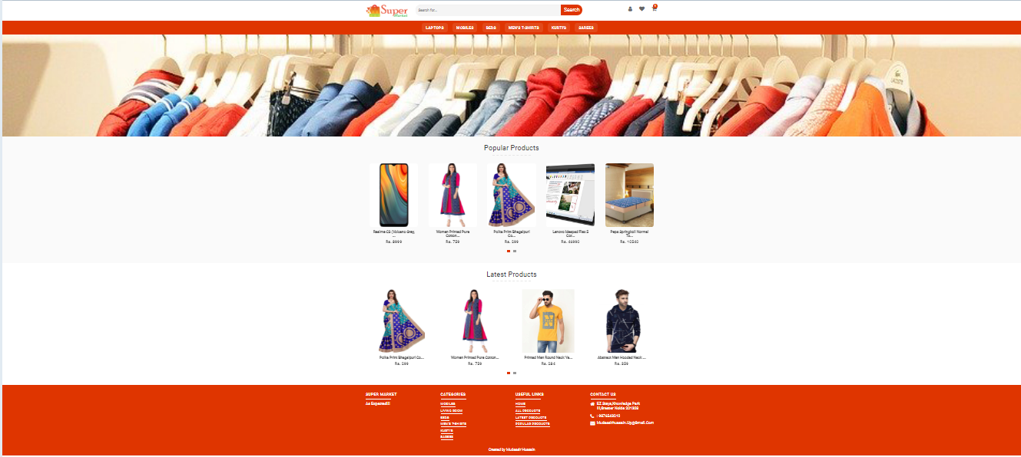

Figure 9: Home Page

* Admin Page

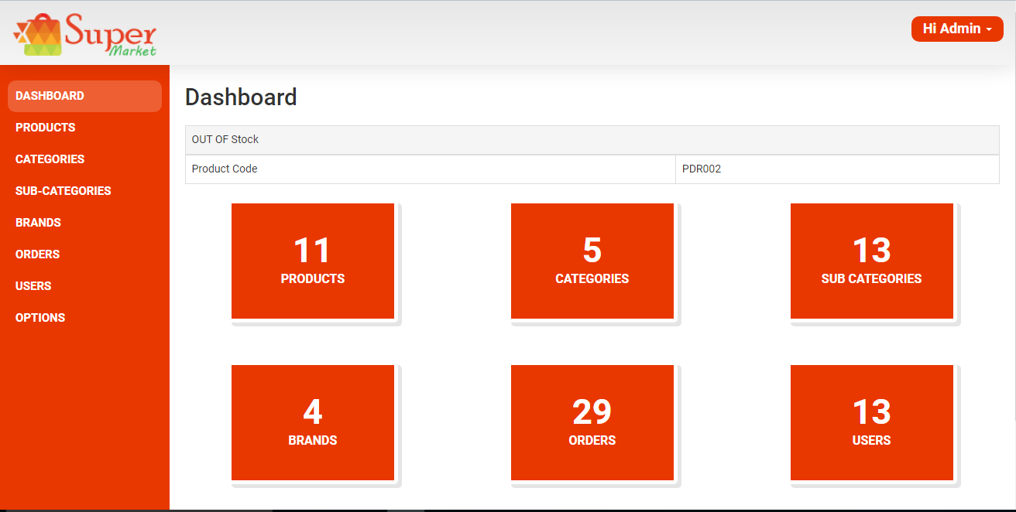

Figure 10: Admin Page

* All Products

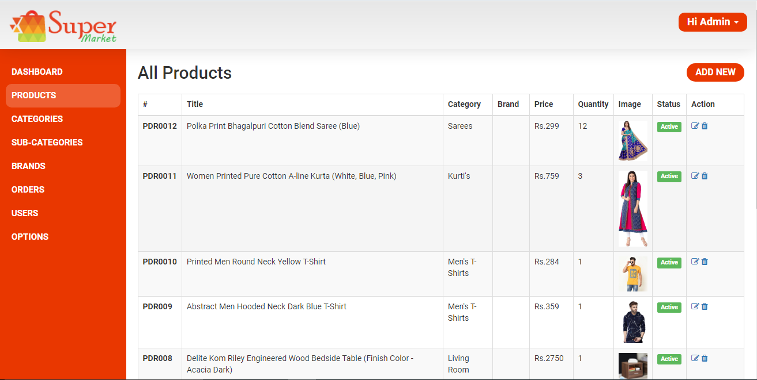

Figure 11: All Products

* Registration Page

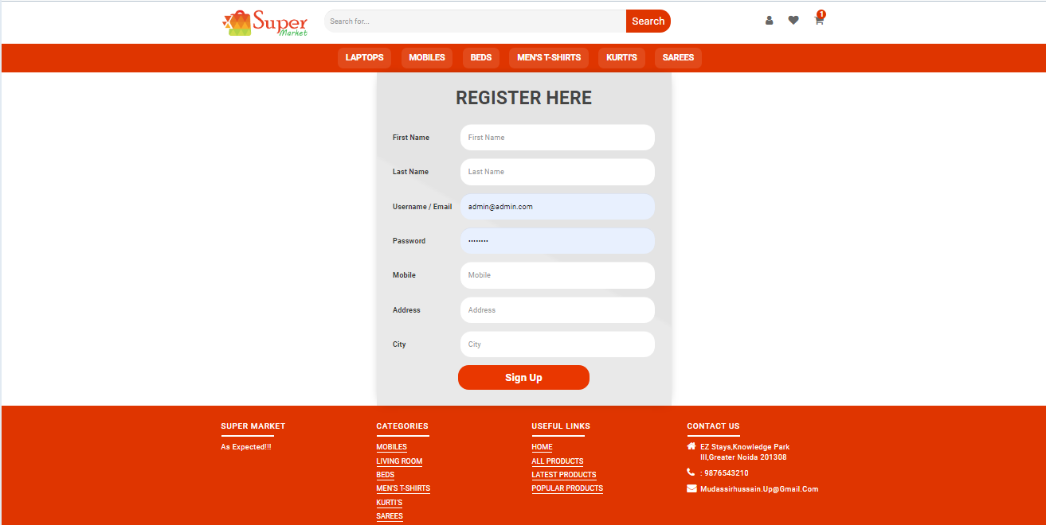

Figure 12: Registration Page

* Login Page

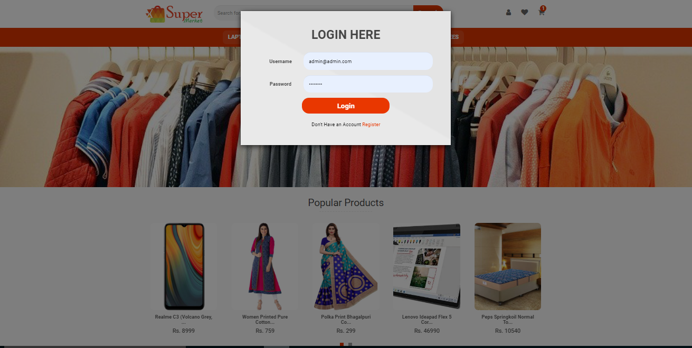

Figure 13: Login Page

* Payment Page

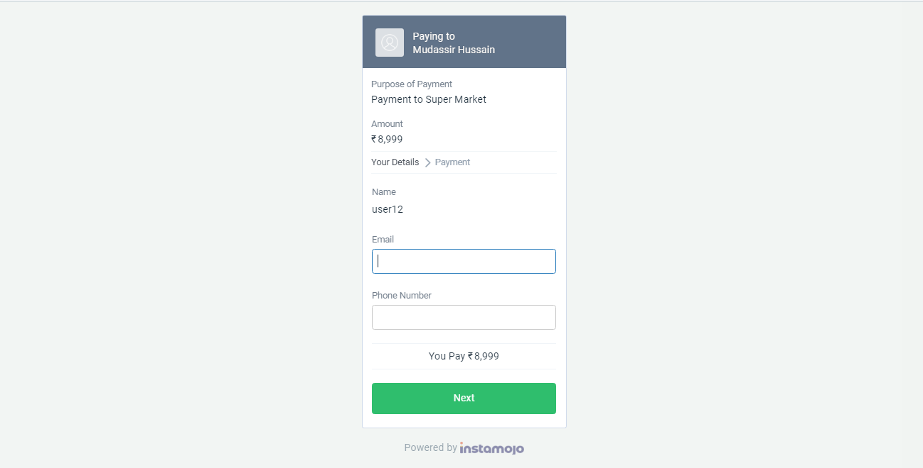

Figure 14: Payment Page